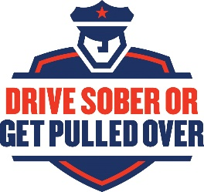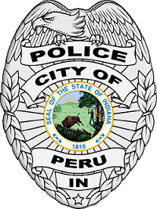

**SUMMER IMPAIRED DRIVING ENFORCEMENT PROJECT**

**PRESS RELEASE**

A select few officers from the Peru Police Department will be participating in the state-wide 2018 Summer Impaired Driving Enforcement Project (“SIDEP”). The Peru Police Department is participating in this project alongside several other Indiana police agencies in order to reduce the number of alcohol-impaired collisions and fatalities on our roadways.

While working SIDEP, officers will be engaging in high-visibility and high-activity traffic enforcement across the City of Peru to remind everyone that if you choose to drive drunk, we will notice you. We will also be conducting at least one sobriety checkpoint during the summer months to encourage people to make the right choices. Before drinking or going out with friends, make sure you have a designated driver who will stay sober and ensure you get home safely.

The officers working SIDEP were chosen by Officer Keith Smith, Peru Police Department’s coordinator for Operation Pull Over programs. “When organizing a team for SIDEP, I chose officers who have proven track records of being able to effectively recognize and act upon signs of impaired driving before and during a traffic stop. These officers have a zero-tolerance policy and are extremely vigilant in getting drunk drivers off the streets.” Smith said. “In other words, if we catch you driving at or above .08, you *will* be arrested. No exceptions. It’s the only way to ensure that impaired drivers won’t get back behind the wheel and risk crashing or hurting someone after we leave.”

SIDEP is funded through a grant from the Indiana Criminal Justice Institute (“ICJI”). Last year, the ICJI asked the Peru Police Department to participate in SIDEP because Miami County ranked near the top in the number of alcohol-impaired collisions. This year, we are grateful that our county did not make this list. Despite that great improvement, the Peru Police Department chose to apply to participate in SIDEP again this year in order to further reduce the number of alcohol-impaired collisions in our area.

The Peru Police Department strives to make the roadways upon which you and your family travel as safe as possible. Please understand that *your* efforts can have a far greater effect than ours by simply ensuring that you and your friends make arrangements to get a sober ride home before going out. If you see someone who is too drunk to drive trying to get in their vehicle, take away their keys and help find them an alternate way of getting home. As always, if you see a vehicle you believe is impaired, call 911 immediately.

SIDEP will run from May 25th, 2018 through September 30th, 2018. Please expect to see more red and blue lights on Peru roadways this summer as we ensure that all operators are driving safely. Remember to move over and slow down: move over one full lane of travel when approaching a stopped emergency vehicle, or slow down to at least ten miles per hour below the speed limit if you are unable to move over.

If you have any questions, comments, or concerns about SIDEP, you are encouraged to contact Officer Keith Smith of the Pere Police Department by leaving a message at 765-473-2150 ext. 524, or by emailing [kasmith@perupd.org](mailto:kasmith@perupd.org). Thank you for doing your part to prevent alcohol-impaired collisions on our roadways. The Peru Police Department wishes everyone a fun, enjoyable, and safe summer.